There are 5 steps for testing :



Step1: Start front-end

Using Terminal with below commands:

***cd frontend***

***npm i***

***npm start***

front-end starts on localhost:3000

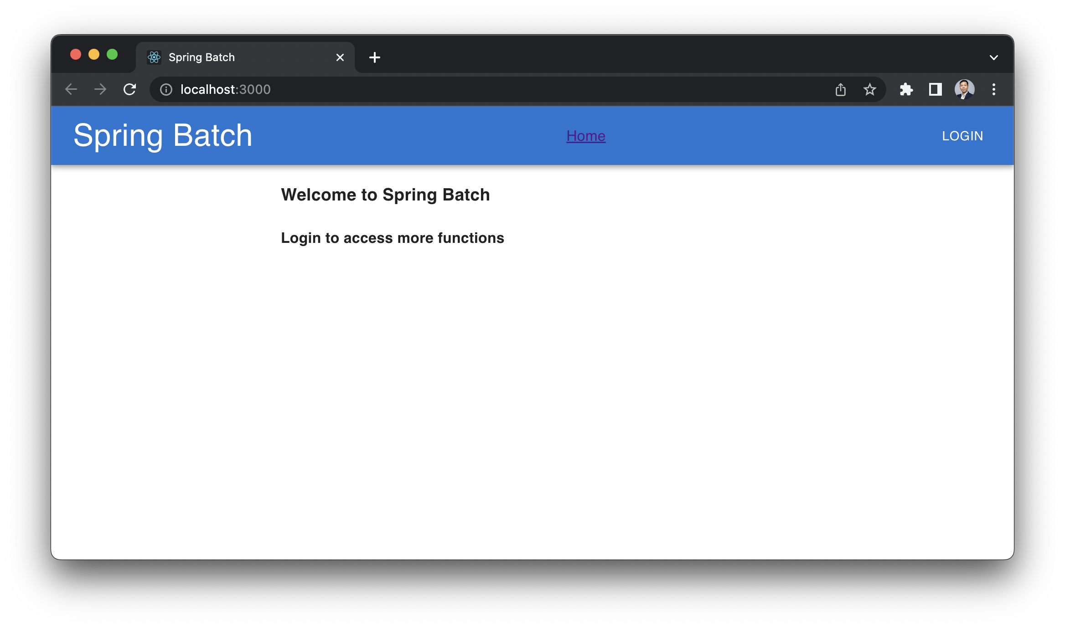

Step2: Start docker-compose

Using terminal with below commands

***docker-compose up***

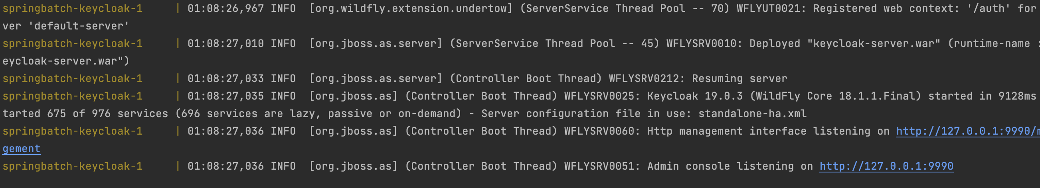

Step 3: Start back-end

Run ‘SpringBatchApplication’

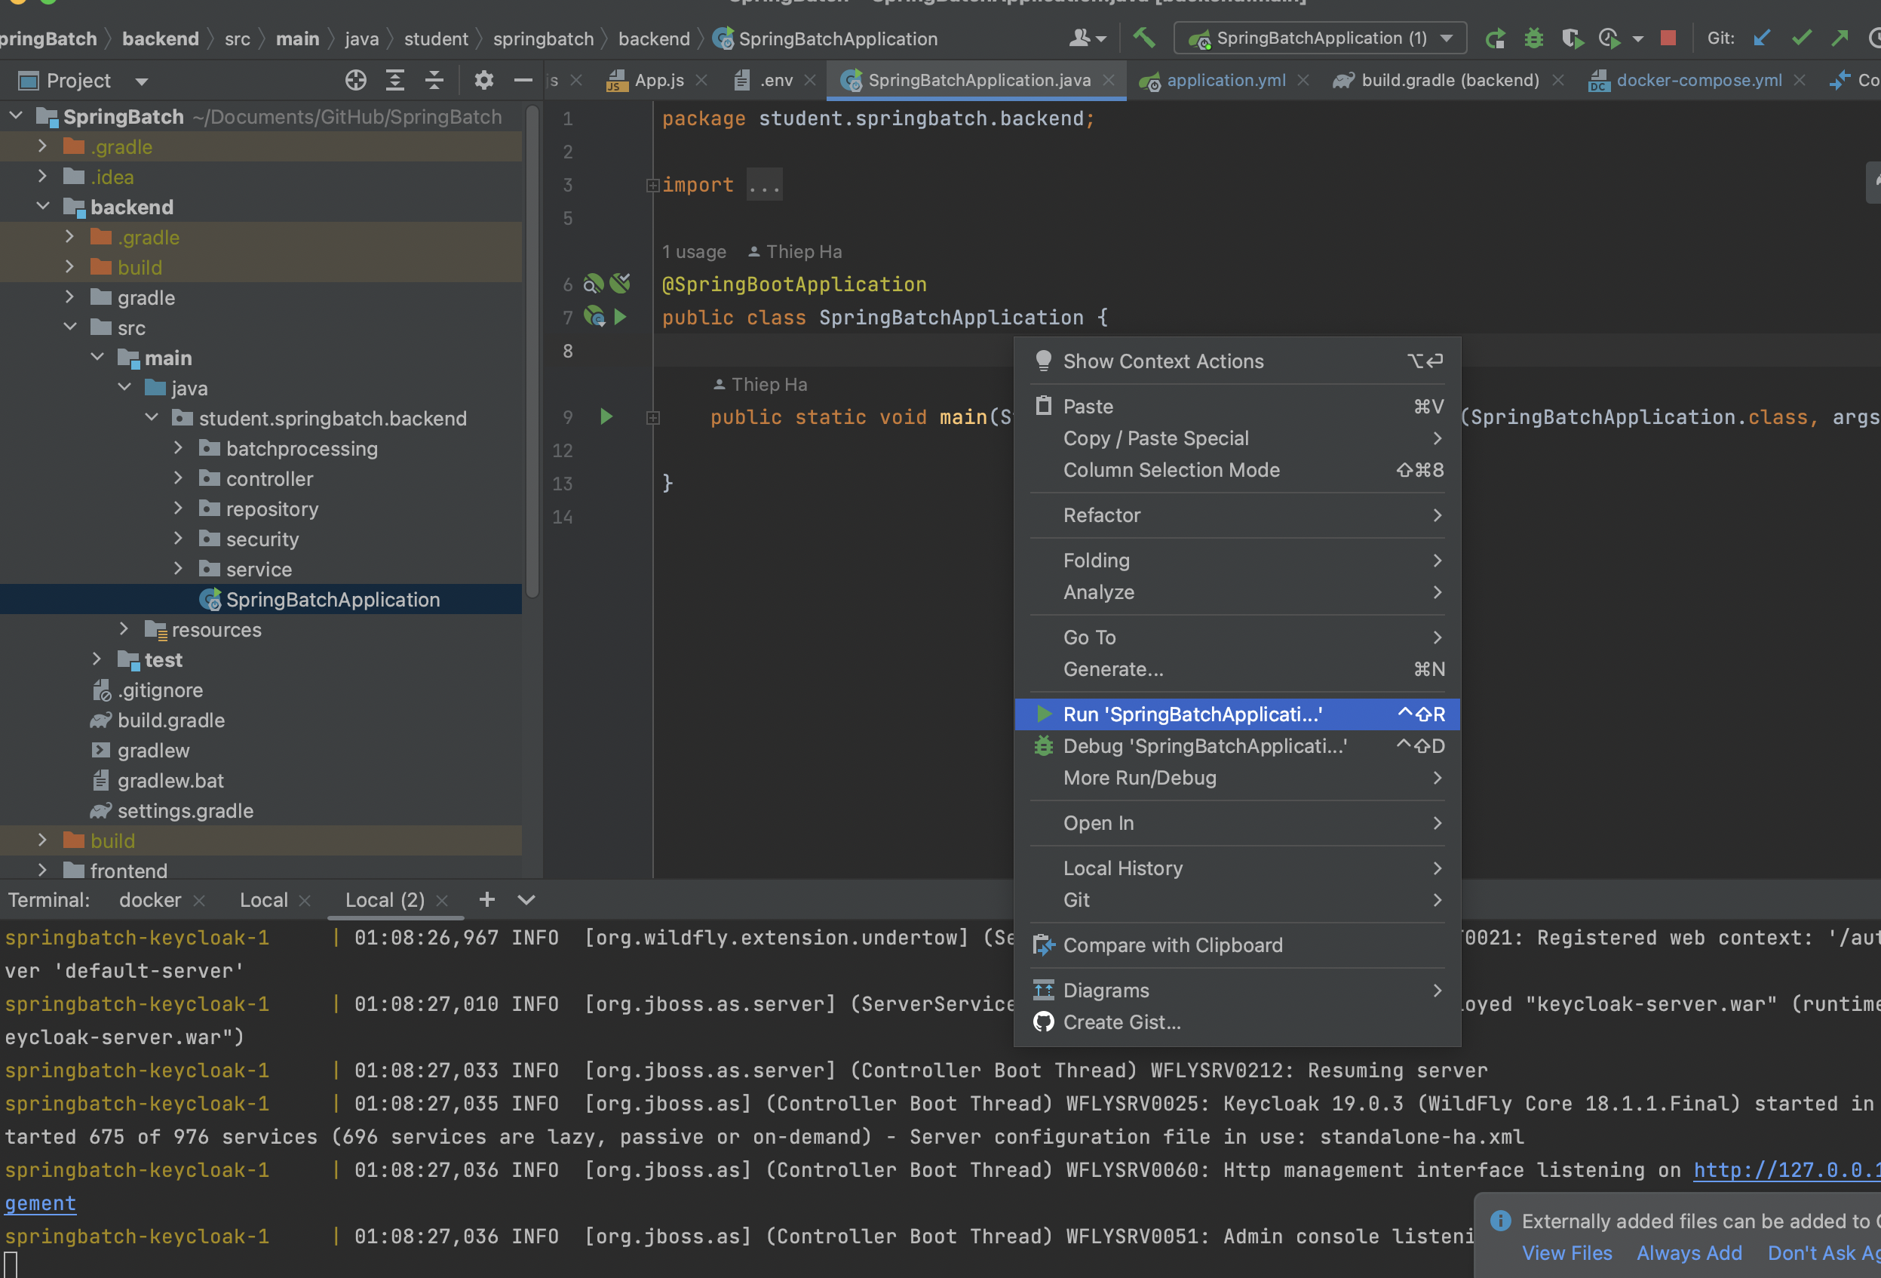

Step 4: test with admin role

* Login with user admin1 / 123

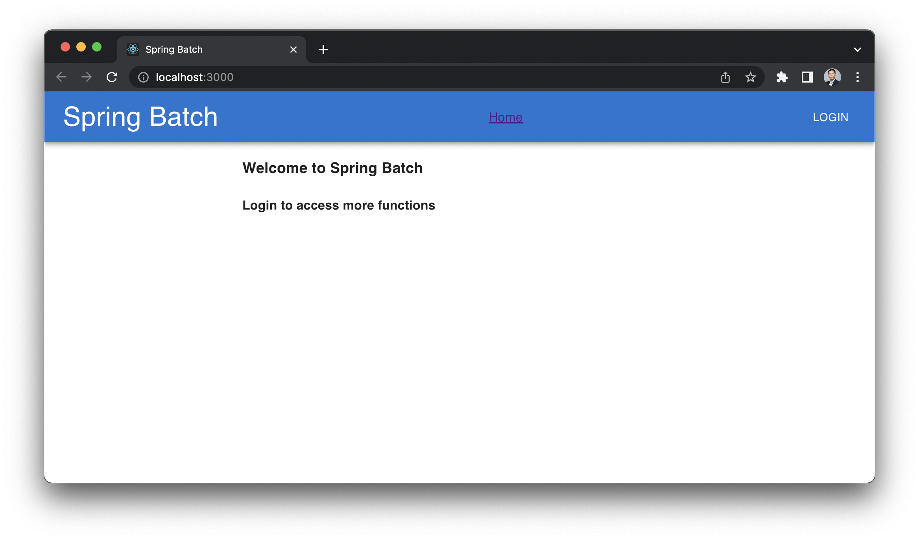

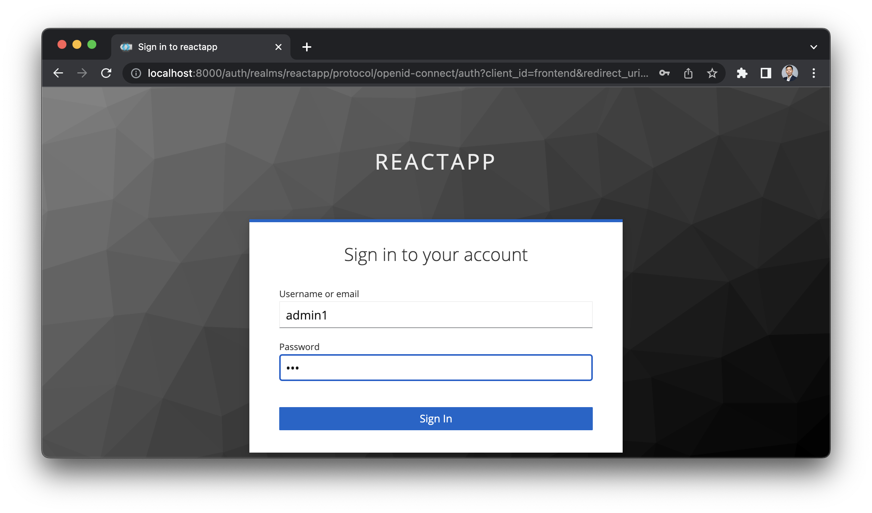

Choose Batch function

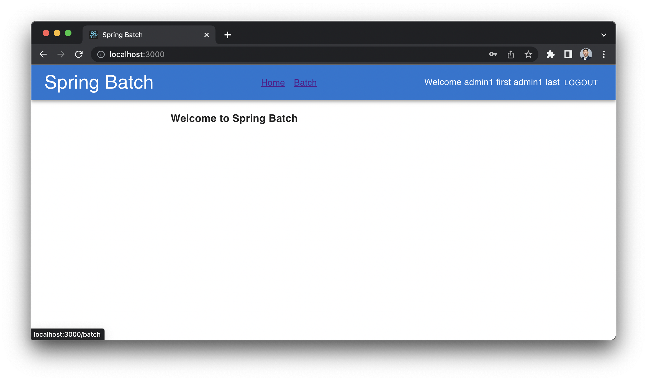

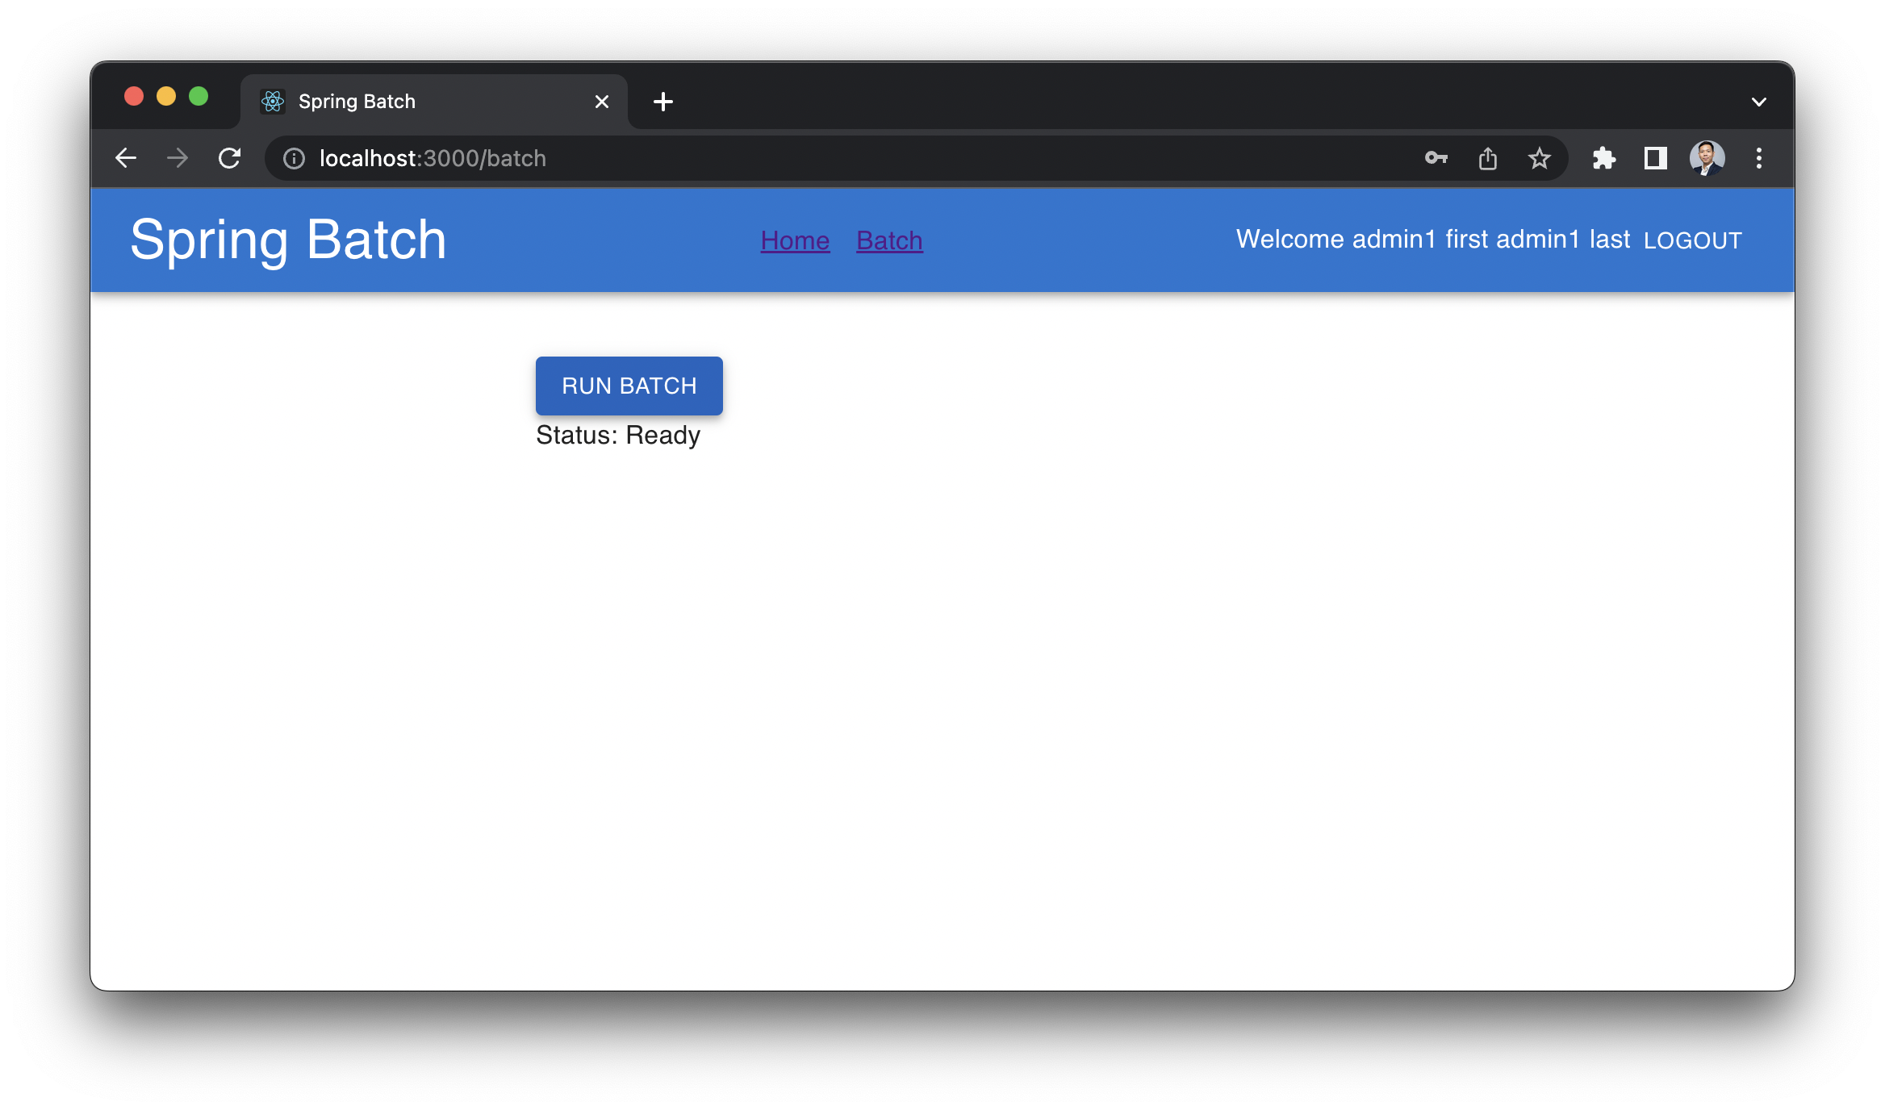

Job completed

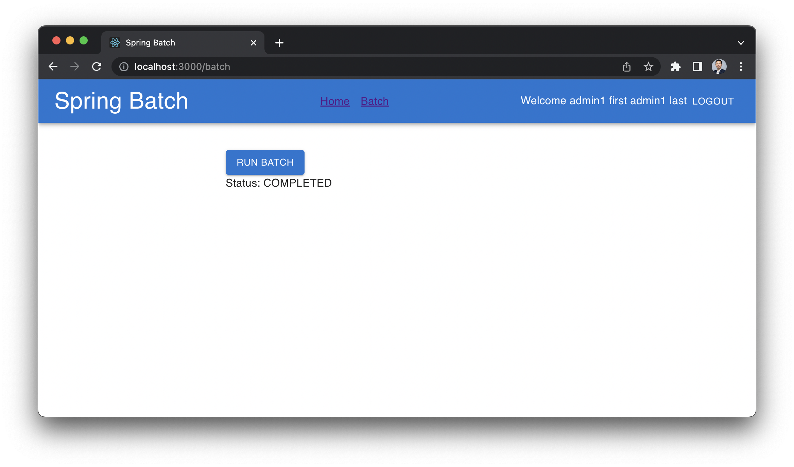

Validate MySQL with user root / dbadmin and database spring-batch

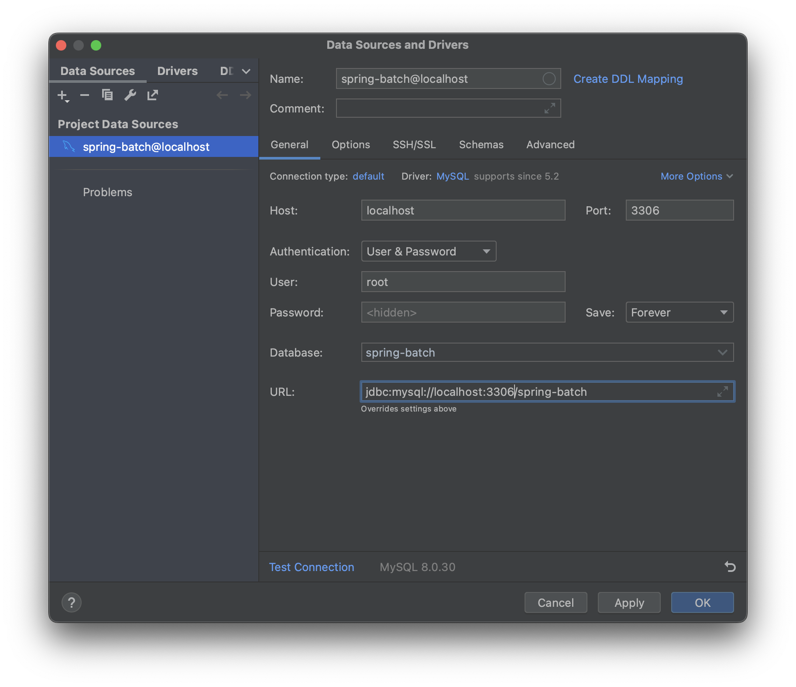

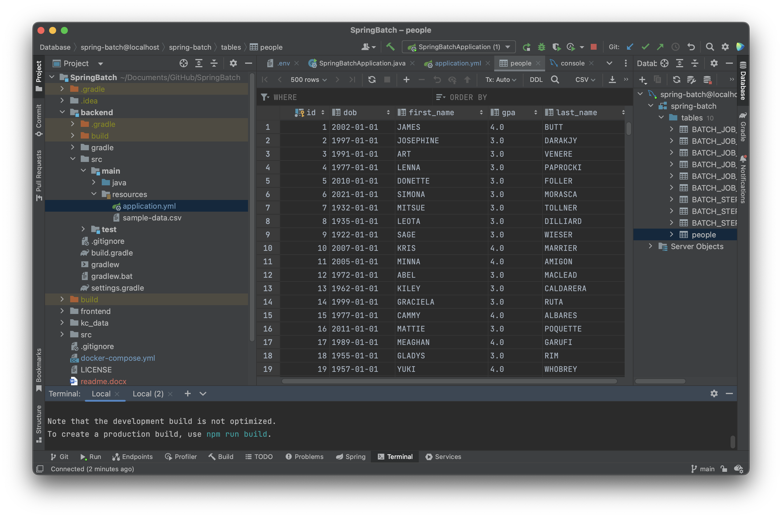

Step 5: Test with user viewer1 / 123

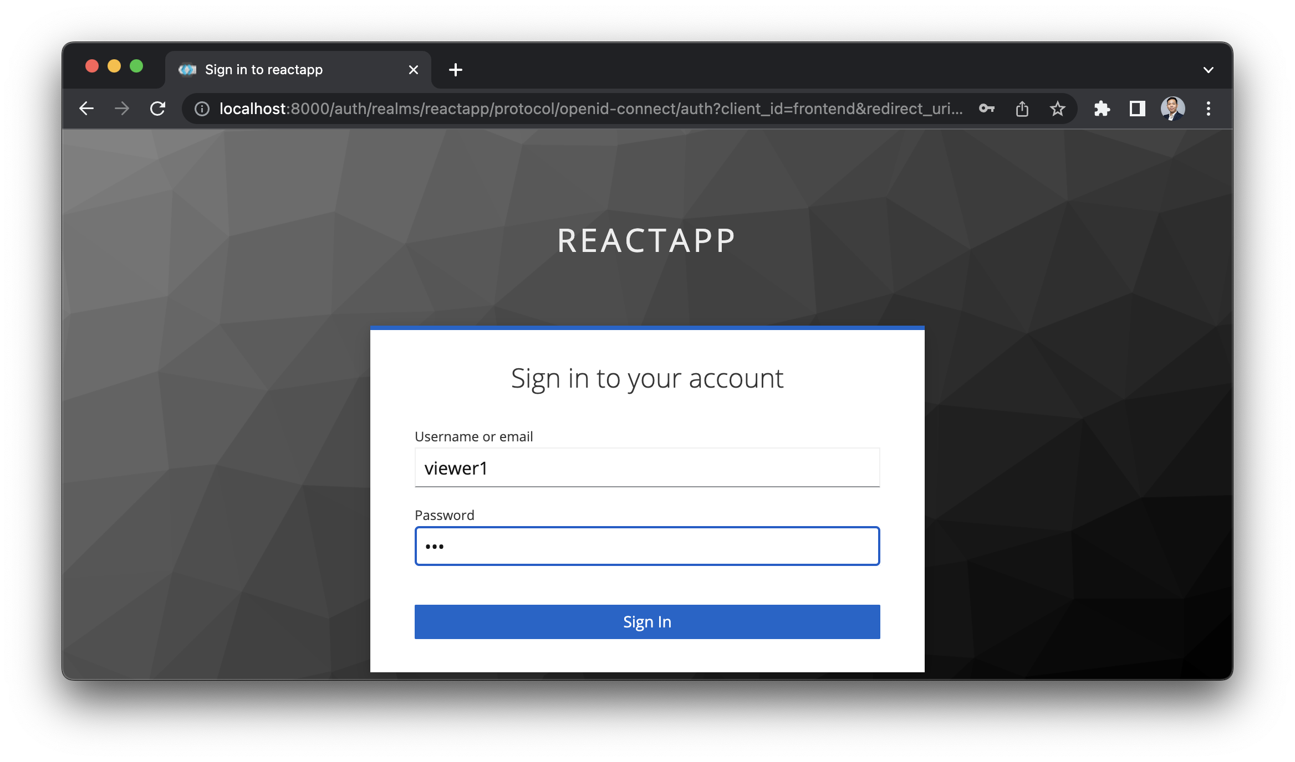

Result Error

